*COMPUTER SCIENCE PROJECT*

*PALASH RAMBHIA*

*CLASS: - 12*

|  |  |
| --- | --- |
| *INDEX* | |
| SR.NO | TOPIC |
| 1. | ACKNOWLEDGEMET |
| 2. | INTRODUCTION |
| 3. | OBJECTIVES OF THE PROJECT |
| 4. | SOURCE CODE |
| 5. | OUTPUT |
| 6. | HARDWARE AND SOFTWARE REQUIREMENTS |
| 7. | BIBLIOGRAPHY |

***ACKNOWLEDGEMENT***

*Apart from the efforts of me, the success of any project depends largely on the encouragement and guidelines of many others. I take this opportunity to express my gratitude to the people who have been instrumental in the successful completion of this project.*

*I express deep sense of gratitude to almighty God for giving me strength for the successful completion of the project.*

*I express my heartfelt gratitude to my parents for constant encouragement while carrying out this project.*

*| gratefully acknowledge the contribution of the individuals who contributed in bringing this project up to this level, who continues to look after me despite my flaws,*

*I express my deep sense of gratitude to the luminary The Principal, Dr. (Mrs.) Veena Shrivastava who has been continuously motivating and extending their helping hand to us.*

*I express my sincere thanks to the academician The vice Principal,* **Ms. Vanita Shetty** *for constant encouragement and the guidance provided during this project*

*I am overwhelmed to express my thanks to _ _for providing me an infrastructure and moral support while carrying out this project in the school.*

*My sincere thanks to Master In-charge, A guide, Mentor all the above a friend, who critically reviewed my project and helped in solving each and every problem, occurred during implementation of the project*

*The guidance and support received from all the members who contributed and who are contributing to this project, was vital for the success of the project. I am grateful for their constant support and help.*

***INTRODUCTION***

*About the project: -*

* Made for travel agency or big travel companies.
* Helps the user to maintain and store database of large number of customers and the trips they have made.

*Application:-*

*Header file used:-*

* #include<iostream.h> - This header file declares the basic C++ streams I/O routines like input, outut, etc.
* #include<fstream> - This data type represents the file stream generally, and has the capabilities of both ofstream and ifstream which means it can create files, write information to files, and read information from files.
* #include<string.h> - **This** is the header in the C standard library for the C programming language which contains macro **definitions**, constants and declarations of functions and types used not only for **string** handling but also various memory handling functions.

*Classes used:-*

1. *Tours:-Tours* is one of the main class. It is used to input data of the customers and contains functions that return various ID's. This class contains function like input_data, show_data, input_trip, show_trips, etc.
2. *File:-*This class plays an important role in storing all the data that the user enters. It creates binary files like user.dat and trips.dat. It has functions that takes in data from customer and store it respectively in the suitable file. It has an object of the Tours class to access the functions of the above class.

*Binary or Text file:-*

1. *Trips.dat:-* It is a binary file that takes all the trip information of all the users and then store it.
2. *User.dat:-* This binary file takes all the user information like name, address, id, etc. and stores it.

*Functions:-*

1. void trip() :- This functions is in the class tours. It displays the different tour packages and inputs the user’s choice.
2. void new_user():- This functions is also in the class tours. It takes input of the user details, like address, name, etc.
3. void show():_ This functions is also in the class tours. It displays all the user details which has been added before.
4. int user_id():- This functions is also in the class tours. It just returns user id of the users.
5. void show_trip():- This functions is also in the class tours. It displays all the trip details of the required user which has been added before.
6. void add_user():- This functions is in the class file. It uses the function new_user and stores the information in the file user.dat.
7. void delete_user():- This functions is also in the class file. It deletes the information of a particular user according to the user id given.
8. void show_users():- This functions is also in the class file. It reads the file “User.dat” and uses the function show from class tours, displaying the user information.
9. void new_trip():- This functions is also in the class file. It uses the function trip from class tours and stores the particular trip of the user in the file trip.dat.
10. void delete_trip():- This functions is also in the class file. It deletes the last added trip of the user.
11. void show_trips():- This functions is also in the class file. It reads the file “Trip.dat” and uses the function show_trip from class trip, displaying the trip information.
12. void user_d():- This functions is also in the class file. It merges the function new_trip and add_user. It first takes input for the user id and checks if the id exists, it shows the all the trips and user details of the user.
13. void edit_user():- This functions is also in the class file. It helps to edit the user information.

***OBJECTIVES OF THE PROJECT***

The objective of this project is to let the students apply the programming knowledge into a real- world situation/problem and exposed the students how programming skills helps in developing a good software.

1. Write programs utilizing modern software tools.

2. Apply object oriented programming principles effectively when developing small to medium sized projects.

3. Write effective procedural code to solve small to medium sized problems.

4. Students will demonstrate a breadth of knowledge in computer science, as exemplified in the areas of systems, theory and software development.

5. Students will demonstrate ability to conduct a research or applied Computer Science project, requiring writing and presentation skills which exemplify scholarly style in computer science

***SOURCE CODE***

#include <iostream>

#include <fstream>

#include <string.h>

using namespace std;

class tours

{

char name[40];

char add[100];

char em[30];

int id=0;

int tid=0;

int cost=0;

int d,y,m;

public:

void trip();

void new_user();

void show();

int user_id();

void show_trip();

};

class file

{

ifstream fin;

ofstream fout;

tours b;

tours a[5];

public:

void add_user();

void delete_user();

void show_users();

void new_trip();

void delete_trip();

void show_trips();

void user_d();

void edit_user();

};

void tours::new_user()

{

cout<<endl<<"Enter user name : ";

cin.ignore();

cin.getline(name,40);

cout<<"Enter user address : ";

cin.getline(add,100);

cout<<"Enter user email-id : ";

cin>>em;

cout<<"Enter user ID : ";

cin>>id;

}

void tours::trip()

{

int i;

cout<<endl<<"************************************"<<endl;

cout<<"* Trip ID * Trip Name *"<<endl;

cout<<"*-----------*----------------------*"<<endl;

cout<<"* 1. * Paris *"<<endl;

cout<<"* 2. * New York *"<<endl;

cout<<"* 3. * London *"<<endl;

cout<<"* 4. * Capetown *"<<endl;

cout<<"* 5. * Sydney *"<<endl;

cout<<"************************************"<<endl;

cout<<"Enter Trip ID : "<<endl;

cin>>tid;

cout<<"Enter Trip date : "<<endl;

cin>>d;

cout<<"Enter Trip month (in numbers) : "<<endl;

cin>>m;

cout<<"Enter Trip year : "<<endl;

cin>>y;

cout<<"Enter total cost : "<<endl;

cin>>cost;

}

void tours::show()

{

cout<<endl<<"User name : "<<name<<endl;

cout<<"User address : "<<add<<endl;

cout<<"User email-id : "<<em<<endl;

cout<<"User ID : "<<id<<endl;

}

void tours::show_trip()

{

int i;

cout<<endl<<"Trip ID : "<<tid<<endl;

if(tid==1)

cout<<"Palace Visiting : Paris "<<endl;

else if(tid==2)

cout<<"Palace Visiting : New York "<<endl;

else if(tid==3)

cout<<"Palace Visiting : London "<<endl;

else if(tid==4)

cout<<"Palace Visiting : Capetown "<<endl;

else if(tid==5)

cout<<"Palace Visiting : Sydney "<<endl;

cout<<"Trip Date : "<<d<<"/ "<<m<<"/ "<<y<<endl;

cout<<"Trip cost : "<<cost<<endl;

}

int tours::user_id()

{

return id;

}

void file::add_user()

{

int i;

tours p[5];

fout.open("user.dat",ios::binary|ios::app);

if(fout)

{

cout<<endl<<endl<<endl<<endl<<endl<<" Welcome to FUTURISTIC Tours And Travels "<<endl<<endl<<endl;

cout<<endl<<"How many users do you want to add (max=5) ? "<<endl;

cin>>i;

for(int j=0;j<i;j++)

{

cout<<endl<<"User "<<j+1<<endl;

p[i].new_user();

fout.write((char*)&p[i],sizeof(p[i]));

cout<<"User added "<<endl;

}

}

fout.close();

}

void file::new_trip()

{

tours c;

int q,flag=0;

fout.open("trips.dat",ios::binary|ios::app);

cout<<endl<<"Enter user Id for whom you want to add a trip : ";

cin>>q;

fin.open("user.dat",ios::binary);

if(fout)

{

while(fin.read((char*)&b,sizeof(b)))

{

if(b.user_id()==q)

{

cout<<endl<<"Enter trip for user "<<endl;

b.trip();

fout.write((char*)&b,sizeof(b));

flag=1;

}

}

}

if(flag==0)

{

cout<<"User not found !!"<<endl;

}

else

cout<<endl<<"Trip added :) "<<endl;

fin.close();

fout.close();

}

void file::show_users()

{

int flag=0;

fin.open("user.dat",ios::binary|ios::app);

while(fin.read((char*)&b,sizeof(b)))

{

b.show();

flag=1;

}

if(flag==0)

{

cout<<endl<<"No users in the list "<<endl<<endl;

}

fin.close();

}

void file::user_d()

{

int iq,flag=0,p=0;

cout<<endl<<"Enter the user ID : "<<endl;

cin>>iq;

fin.open("user.dat",ios::binary|ios::app);

while(fin.read((char*)&b,sizeof(b)))

{

if(b.user_id()==iq)

{

b.show();

flag=1;

}

}

if(flag==0)

{

cout<<endl<<"User not found !! "<<endl;

}

fin.close();

fin.open("trips.dat",ios::binary|ios::app);

while(fin.read((char*)&b,sizeof(b)))

{

if(b.user_id()==iq)

{

b.show_trip();

p=1;

}

}

if(p==0&&flag==1)

{

cout<<endl<<"No current trip for user! "<<endl;

}

fin.close();

}

void file::delete_user()

{

int id,flag=0;

fin.open("user.dat",ios::binary);

fout.open("temp.dat",ios::binary);

cout<<endl<<"Enter user's ID you want to delete : ";

cin>>id;

while(fin.read((char*)&b,sizeof(b)))

{

if(id!=b.user_id())

{

fout.write((char*)&b,sizeof(b));

}

else

flag=1;

}

if(flag==0)

{

cout<<endl<<"Invalid User ID " <<endl<<endl;

}

else

{

cout<<endl<<"User deleted "<<endl<<endl;

}

fin.close();

fout.close();

remove("user.dat");

rename("temp.dat","user.dat");

}

void file::edit_user()

{

int id,flag=0;

fin.open("user.dat",ios::binary);

fout.open("temp.dat",ios::binary|ios::app);

cout<<endl<<"Enter user id whose data you want to modify "<<endl;

cin>>id;

while(fin.read((char*)&b,sizeof(b)))

{

if(id==b.user_id())

{

fin.seekg(-1*sizeof(b),ios::cur);

b.new_user();

flag=1;

}

fout.write((char*)&b,sizeof(b));

}

if(flag==0)

{

cout<<"Invalid user ID "<<endl;

}

else

cout<<endl<<"User details modified "<<endl;

fin.close();

fout.close();

remove("user.dat");

rename("temp.dat","user.dat");

}

int main()

{

int i;

char ch;

file a;

do

{

cout<<" *HOMEPAGE* "<<endl<<endl;

cout<<" ________________________________ "<<endl<<endl;

cout<<" | 1. New User. |"<<endl<<endl;

cout<<" | 2. New trip. |"<<endl<<endl;

cout<<" | 3. All user information. |"<<endl<<endl;

cout<<" | 4. Edit User. |"<<endl<<endl;

cout<<" | 5. Delete User. |"<<endl<<endl;

cout<<" | 6. search User details. |"<<endl<<endl;

cout<<" |________________________________|"<<endl<<endl;

cout<<" Enter your choice : ";

cin>>i;

switch(i)

{

case 1: a.add_user();

break;

case 2: a.new_trip();

break;

case 3: a.show_users();

break;

case 4: a.edit_user();

break;

case 5: a.delete_user();

break;

case 6: a.user_d();

break;

default: cout<<"Invalid choice. "<<endl;

break;

}

cout<<endl<<"Do you want to continue ? "<<endl;

cin>>ch;

cout<<endl<<endl;

}while(ch=='y'||ch=='Y');

cout<<endl<<"Thank You for choosing us. "<<endl;

return 0;

}

***OUTPUT***

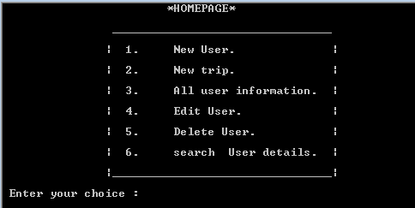

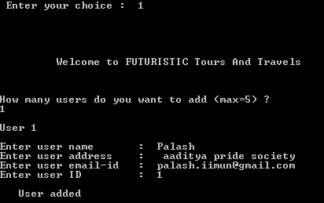

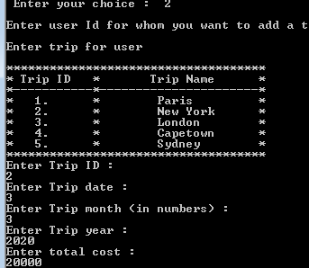

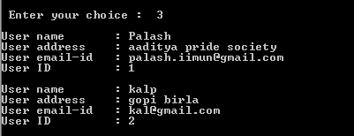

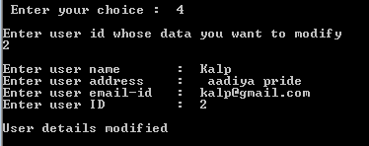

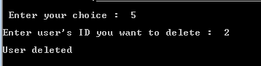

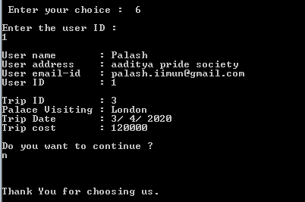

***HARDWARE AND SOFTWARE REQUIREMENTS***

***I.OPERATING SYSTEM : WINDOWS 7 AND ABOVE***

***II. PROCESSOR : PENTIUM(ANY) OR AMD***

***ATHALON(3800+- 4200+ DUAL CORE)***

***III. MOTHERBOARD : 1.845 OR 915,995 FOR PENTIUM 0R MSI***

***K9MM-V VIA K8M800+8237R PLUS***

***CHIPSET FOR AMD ATHALON***

***IV. RAM : 512MB+***

***V. Hard disk : SATA 40 GB OR ABOVE***

***VI. CD/DVD r/w multi drive combo: (If back up required)***

***VII. FLOPPY DRIVE 1.44 MB :***

***VIII. MONITOR 14.1 or 15 -17 inch***

***IX. Key board and mouse (If Backup required)***

***X. Printer : (if print is required – [Hard copy])***

***SOFTWARE REQUIREMENTS:***

1. ***Windows OS***

***BIBLIOGRAPHGY***

* [***www.google.com***](http://www.google.com)
* ***www.*** ***Geeksforgeeks.com***
* ***Sumit Arora textbook***
* ***Allinone reference book***